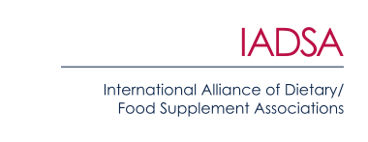
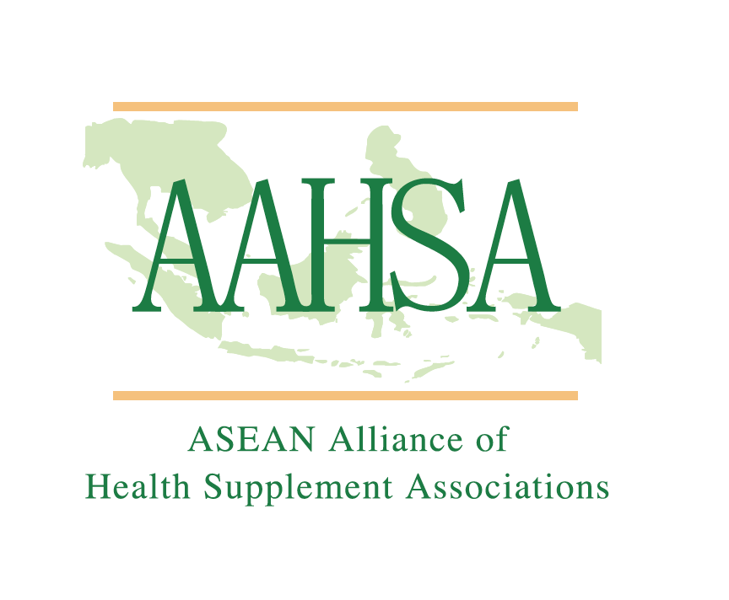

30 November 2020

PRESS RELEASE

‘A blueprint for success’ – Public-private co-operation
helps ASEAN on the road to harmonisation

A new report has highlighted how unprecedented levels of co-operation between industry and government have helped ASEAN to develop an agreement to harmonise the cross-border regulation of health supplements.

After 16 years of complex discussions, ASEAN’s 10 Member States are now close to finalising the ASEAN Agreement on Regulatory Framework for Health Supplements. Once ratified, it will reduce non-tariff technical barriers to the trade in supplements between ASEAN countries and usher in a new era for the supplement sector in Southeast Asia.

The report – ASEAN’S Road to Harmonisation – explains the background to the agreement and reveals how industry associations and regulators worked closely together on the details. It has been published by the ASEAN Alliance of Health Supplement Associations (AAHSA) and the International Alliance of Dietary/Food Supplement Associations (IADSA).

The decision to harmonise was originally taken in 2004. Early on in the development of the agreement, the supplement sector was invited to contribute expert scientific input. In response, in 2006, industry groups across ASEAN formed AAHSA to act as a united voice during the harmonisation process. Reflecting its positive contribution, AAHSA is an accredited Business Organisation officially listed as an ‘Entity Associated with ASEAN’.

Daniel Quek, AAHSA Chairman, said: “The way in which industry and regulators have worked together in ASEAN can act as a blueprint for success throughout the world. Through AAHSA, the private sector has been able to demonstrate its commitment to achieving the same aims as government. In particular, it played an important role in developing the 10 annexes that form the backbone of the agreement, covering important topics such as a negative list of banned ingredients, substantiation of safety and health claims, labelling requirements, and more.”

AAHSA worked alongside IADSA, the global association of the food supplement sector, with members from six continents. Simon Pettman, IADSA Executive Director, commented: “The associations provided expertise from the beginning of this process, and to have reached this point is a great success story not just for ASEAN but also for the world, because it provides an excellent model for others to follow.”

He continued: “In creating the conditions for supplement businesses in ASEAN to thrive, harmonisation acts as a catalyst for attracting investment by health supplement players from both within the region and elsewhere in the world, leading to an increase in production capacity, research & development, economic growth and job creation in the region.”

Governments in ASEAN consider health supplements to be a priority sector. The market continues to grow globally, which means there is a shared desire among ASEAN countries to ensure products sold in the region are manufactured to high levels of safety and quality.

Furthermore, there is a recognition that growth in the global market for health supplements represents an opportunity for ASEAN to leverage its position as a world leader in the sector – particularly in the area of herbal ingredients, capitalising on the significant biodiversity in the region.

Daniel Quek said that harmonisation would provide a sizeable boost to the supplements market in the region. “The health supplements market in ASEAN is forecast to record a compound annual growth rate of 5.6% between 2018 and 2026, to reach a value of US$10.6 billion,” he explained. “AAHSA estimates that harmonisation has the potential to add up to 8% to this, driven largely by the reduction of technical obstacles to trading across borders in ASEAN.”

Simon Pettman added: “Aligning ASEAN’s technical requirements and guidelines for health supplements more closely with the rest of the world makes local companies more competitive on the global stage and opens up new opportunities for them to export. Most important of all, harmonisation helps to protect consumers living in ASEAN Member States by setting rigorous standards and providing access to safe and high-quality products.”

ASEAN (the Association of Southeast Asian Nations) was established in 1967 to encourage economic growth in Southeast Asia. Its 10 Member States are Brunei Darussalam, Lao PDR, Philippines, Cambodia, Malaysia, Singapore, Indonesia, Myanmar, Thailand and Viet Nam. For more information visit asean.org.

ENDS

For more information, or to obtain a PDF copy of the new AAHSA-IADSA report, please contact:
Richard Clarke, Ingredient Communications
Tel: +44 (0) 7766 256176
Email: richard@ingredientcommunications.com
About IADSA
Established in 1998, IADSA is an international body comprising member associations and companies operating in the global supplements sector. Bringing together food supplement associations from six continents, IADSA is a trusted source of information and runs regional and national regulatory, scientific and technical programmes in many parts of the world, supporting and advising governments and other stakeholders in relation to the development and implementation of regulation and policy. IADSA also works with companies and authorities to build national associations in countries where they do not already exist. IADSA’s full name is International Alliance of Dietary/Food Supplement Associations.

About AAHSA
The ASEAN Alliance of Health Supplement Associations (AAHSA) represents the health supplement industry in the member countries of the Association of Southeast Asian Nations (ASEAN). AAHSA was created in 2006 to work with the regulatory bodies of ASEAN to achieve harmonisation in health supplements across the region. AAHSA now brings together seven national health supplement associations which work closely with their national authorities on legislation and collaborate together as AAHSA on regional issues.

www.globenewswire.com/news-release/2020/01/21/1972700/0/en/ASEAN-Dietary-Supplements-Market-Size-to-Reach-USD-10-60-Billion-by-2026-Increasing-Health-Consciousness-among-the-Urban-Populace-to-Fuel-the-Market-Fortune-Business-Insights.html

